Board of Trustees
Boards – whether they be boards of trustees of state schools, boards of independent schools, or boards governing early childhood education provision – are the entities charged with ensuring the realisation of the human right to education for the children in their school or centre.
To be in accordance with community aspirations, New Zealand education policy – and international human rights treaty obligations promoted and formally accepted by New Zealand – the education they provide must be aimed at ‘development of the child’s personality, talents and mental and physical abilities to their fullest potential’, and ‘preparation for responsible life in a free society’.
It must be an education that:
- respects children’s human rights (including rights to dignity, identity, safety, expression & participation, justice)
- helps realise their human rights (including rights to health, work, an adequate standard of living, a sustainable environment)
- promotes the human rights of others.
(see for example Universal Declaration of Human Rights article 26; International Covenant on Economic, Social and Cultural Rights article 13; Convention on the Rights of the Child articles 28 & 29)
In its composition and relationship to parents as key stakeholders, the board also represents obligations to take into account the rights and duties of ‘parents, legal guardians, or other individuals legally responsible’ for children, including their “prior right to choose the kind of education that shall be given to their children” (UDHR article 26.3).

NZ Education policy
These international commitments are reflected in the requirement for state schools to provide an education that is in accordance with the National Education Guidelines, comprising the National Education Goals, New Zealand Curriculum, and National Administration Guidelines.
The following National Education Goals (NEGs) are human rights-related:
“All students to realise their full potential as individuals” (NEG 1)
“All students to…develop the values needed to become full members of New Zealand's society” (NEG 1)
“Equality of educational opportunity for all New Zealanders” (NEG 2)
“Respect for the diverse ethnic and cultural heritage of New Zealand people...and New Zealand's role…as a member of the international community of nations” (NEG 10)

NZ Curriculum requirements
‘Each board of trustees, through the principal and staff, is required to develop and implement a curriculum for students’ based on The New Zealand Curriculum, ie one :
- underpinned by and consistent with the principles
- in which the values are encouraged and modelled and are explored by students
- that supports students to develop the key competencies
- drawing on the achievement objectives
- tailored to the learning needs and interests of the school's students
(see New Zealand Curriculum p44, and Foundation Curriculum Policy Statements issued 12 Nov 2007)

The curriculum principles reflect human rights principles:
- education should be directed to development to fullest potential (‘high expectations’)
- those implicit in the Treaty of Waitangi
- respect for diversity
- inclusion
- community engagement
- citizenship (involving rights and responsibilities).
The values to be ‘evident in the school’s philosophy, structures, curriculum, classrooms, and relationships’ include ‘respect for self, others and human rights’, and human rights-related values such as respect for diversity and equity, ecological sustainability and integrity.
Key competencies such as ‘relating to others’ and ‘participating and contributing’ are strengthened through an understanding of and commitment to human rights.
A range of achievement objectives, particularly in Social Studies and Health & PE, relate specifically to human rights; many more can be effectively addressed using a human rights lens.

Other requirements
Under the National Administrative Guidelines (NAGs), boards of trustees are required to
‘provide a safe physical and emotional environment for students’ (NAG 5)
and ‘be a good employer’ (NAG 3), which involves adhering to human rights principles.
Boards of Trustees of state schools have human rights-related responsibilities under the Education Act 1989, the State Sector Act 1988, the Crown Entities Act 2004, the Official Information Act 1982, the Privacy Act 1993, the Health and Safety in Employment Act 1992, the Human Rights Act 1993, and the New Zealand Bill of Rights Act 1990.

human rights & responsibilities: ‘A useful framework’
A human rights framework can be an indispensible part of the board’s toolkit for effective school governance, helping to make sense of the role of the board, tying together the key things for which boards have responsibility.
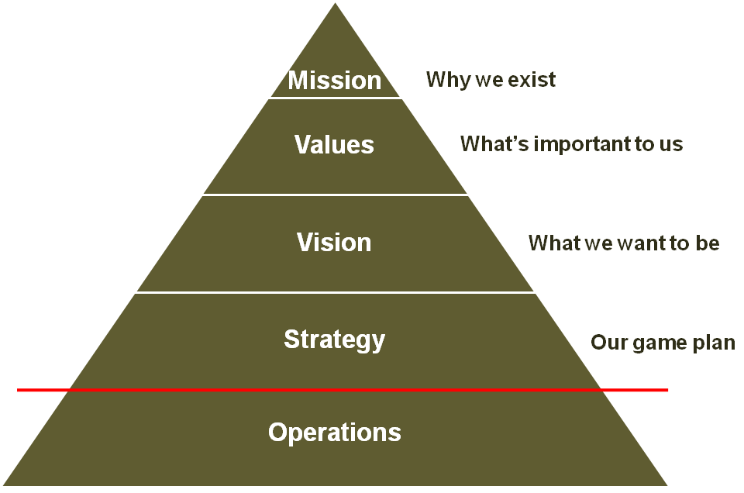
Conceptualising the mission of the school as delivering on the right of every child to an education that respects and helps realise their human rights and those of others,
- helps focus efforts on really counts
- links to critical values
- helps tie together such critical areas as curriculum, discipline and school culture.

A strategy map, linked to balanced scorecard methodology – shown to lift corporate performance and increasingly used by school boards in the USA and UK – can communicate the human rights mission of the school to all stakeholders and assist the board in monitoring school performance.

