Human rights-based education:
fulfilling NZ education policy
Much of the policy language known to New Zealand educationists can be traced back to the Director of Education appointed by Peter Fraser, C E Beeby. In the 1940s the goal of good education for all New Zealand children was an integral and explicit part of the Government’s overall human rights agenda. The language ‒ "every person, whatever his level of academic ability, whether he be rich or poor, whether he live in town or country, has a right as a citizen to a free education of the kind for which he is best fitted and to the fullest extent of his powers” – was part of the general human rights discussion.
National Education Guidelines
All students to realise their full potential as individuals
(National Education Goal 1)
All students to…develop the values needed to become full members of New Zealand's society
(National Education Goal 1)
Equality of educational opportunity for all New Zealanders
(National Education Goal 2)
Respect for the diverse ethnic and cultural heritage of New Zealand people...and New Zealand's role…as a member of the international community of nations
(National Education Goal 10)
Each Board of Trustees is required to
foster student achievement by providing teaching and learning programmes which incorporate the New Zealand Curriculum
(National Administration Guideline 1)
provide a safe physical and emotional environment for students
(National Administration Guideline 5)
It is not surprising therefore that a strong human rights theme runs through New Zealand’s Education Act, National Education Goals, Curriculum and National Administrative Guidelines.
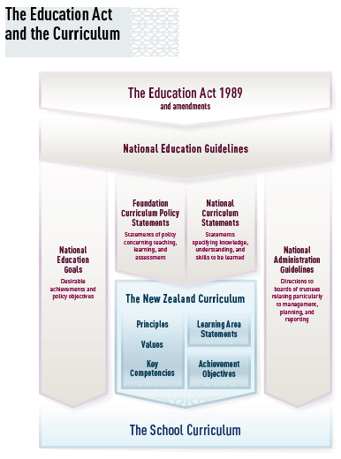

1939 Annual Report of the Department of Education

