
Evidence of impact:
the Hampshire case study
One of the most comprehensive approaches to human rights-based education has been rolled out by Hampshire County Council in the United Kingdom.
Hampshire’s programme is based on the UN Convention on the Rights of the Child and evidence of positive impact on pupils and schools in both Cape Breton (Canada) and Hampshire.
Piloted and then rolled out in all primary schools as Rights, Respect, Responsibilities, it is now being introduced county-wide for all schools, and the approach is being adopted in four other UK counties with support from the UK Committee for Unicef and the UK Department for Children Schools and Families.
The Convention provides a global consensus on societal values for all children and can guide our behaviours.
It promotes universal principles of the need to protect the rights of all children, help them to understand their responsibilities and offers a framework for teaching and learning.
Hampshire County Council

Hampshire has reported:
- overall very positive early experience
- implementation has not hampered by excessive challenges
- widespread agreement on the need to sustain and expand the initiative
- positive impact on students’ behaviors and teachers.

Improvements in well-being & achievement
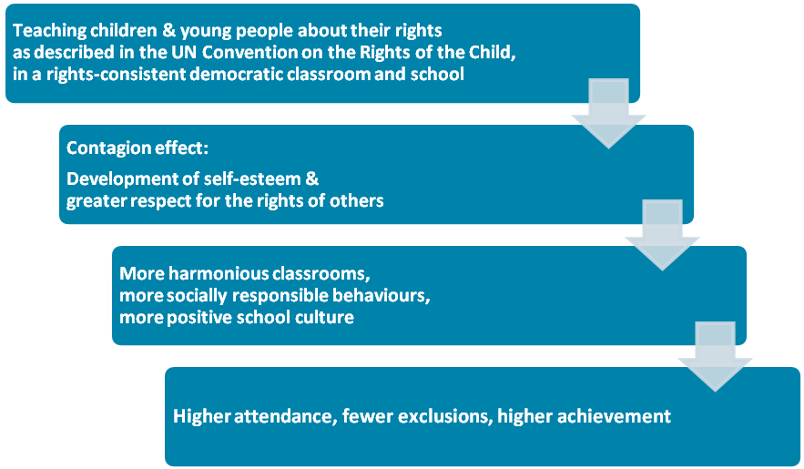

Impact on values/competencies

EXCELLENCE, INTEGRITY, SELF-RESPECT/MANAGING SELF
- Higher student self-esteem
- Students take of ownership of their learning and behavior (e.g., optimum learning and safe playgrounds are understood to be their rights and their responsibilities).
“I’ve been doing better since I found out that some children don’t have the right to education.”
“Through doing this I feel better about myself. I’m able to stand up to my step-dad – and my mum is too.”

DIVERSITY, EQUITY/RELATING TO OTHERS
- Students show a greater concern for themselves, each other and children in other parts of the world
- Students’ approach to resolving conflict with each other and adults is less adversarial
- Less bullying
- More positive attitudes towards diversity in society and reduction of prejudice
“Pupils’ personal development is outstanding … Pupils value and respect friendship and as one child wrote, ‘You have the right to friendship ... but the responsibility to look after your friends’.”
—Review of a Hampshire rights respecting school: Oakley Infant School – March 2006
“Children’s personal development and well-being are outstanding, reflecting the high priority the school gives this. The school’s excellent programme of Rights, respect and responsibilities (RRR) reinforces this approach. These principles are applied well in lessons and in many other aspects of the school. Teachers model these values well in all of their work.”
—Review of a Hampshire rights respecting school: Berrywood Primary School – March 2006
“The school’s involvement in the Rights, Respect and Responsibilities programme has contributed to outstanding spiritual, moral, social and cultural development for pupils. They say that, ‘they have learnt to listen to others, be kind to each other and take turns more readily’.
— Review of a Hampshire rights respecting school: Tweseldown Infant School – May 2006

COMMUNITY & PARTICIPATION/PARTICIPATING & CONTRIBUTING
- Students begin to behave like citizens, with stronger citizenship behaviours in three areas: respect for the rights of others, respect for property, and level of participation.
- Students more likely to attend school
- Students less likely to be excluded

INNOVATION, INQUIRY & CURIOSITY/THINKING, USING LANGUAGE, SYMBOLS & TEXTS
- Increased use of the language of rights and the use of rights as a framework for decision-making.
- Rights discourse seen in students’ analysis of issues (e.g., in student newspaper), and resolution of behavioral issues
- Students’ language becomes more sophisticated and they are more likely to use higher order thinking. Attainment in English improves.

Impact on academic achievement
- Enhanced national test scores (SATS) are reported for pupil SATS in English, maths, and science.
This is assumed to come from: increased confidence, increased student engagement, involvement and self-regulation in learning and behaviour, acceptance of responsibility for own learning, decreased competitiveness and increased sense of belonging to the group.

Impact on teachers
- Teachers less confrontational with children when attempting to gain compliance or deal with behaviour issues
- Being more democratic in the classroom is increasing their authority (rather than the often-feared diminishment) through increasing the pupil’s respect for them.
- Significantly lower levels of exhaustion and a lower sense of depersonalisation.

Impact on school management
- Greater coherence to school development strategies
- More favourable Ofsted reports

BY 10 YEARS OF AGE most children in rights-respecting primary schools can…
- Give examples of how their own actions have consequences –positive and negative –for the rights of others globally
- Have a close working familiarity with the articles of the UN Convention on the Rights of the Child
- Give a range of examples of rights abuses from the immediate context of the school to the global context
- Use the UNCRC as a framework for making moral judgments across a range of issues concerning justice and sustainability
- Understand that their own rights are linked with a wide range of personal responsibilities
- Critically evaluate the actions of those with power, including governments, through reference to human rights

Some recurring themes in young people’s comments
“Since learning what our rights really are it makes me more confident.”
“Now that we know our rights we can see we need responsibilities too.”
“If someone said “what are you learning about rights and responsibilities for? I’d say: “Because it is the most important lesson you can learn.”
“Our classroom charter is based on the UNCRoC. This is better than rules because they are for all the time.”
“The UNCRoC is like a code for living.”
“We know how to sort things out between ourselves better.”
“Inequality and poverty are about the denial of human rights.”
“Everyone is given the same opportunities and treated equally.”
“They push us to learn, but in a fair way.”
“Rights improve behaviour because of responsibilities to help keep everyone safe and not destroy things and because we have to respect others’ rights.”
“To be respected and not be called a name or hurt because of your religion.”
“Keep the teachers because the children feel comfortable talking to them, we’re not scared or uncomfortable to talk if we are getting bullied and we’re always helped.”
“I would like it if we had a hospital at the school. Then there would be no more eternity leaves – the teacher could have the baby at lunch time if there was a hospital and then come back to class. Too many teachers are on eternity leave and we miss them.”

Some recurring themes in teachers and school supervisors’ comments
“A rights & responsibilities approach has helped improve relationships between young people.”
“Much less falling out. Much greater readiness to take responsibility for sorting things out themselves.”
“Young people look out for each other more.”
“The atmosphere in the classroom encourages you to be more adventurous in your teaching.”
“It is really important for we adults to model rights-respecting behaviour in all we do and say.”
“The language development through adopting a rights & responsibilities approach has been powerful.”
“Young people grow to expect to have a say in their own learning. They want to get involved more.”

Why does it work?
Principals and inspectors in Hampshire believe that the approach has these impacts for three main reasons:

Empowerment
- Young people and adults working with them find the UNCRoC empowering and helps to improve their relationships
- It appeals to children’s self interest – they’re already citizens; they have rights now. They don’t have to earn them or wait or adulthood.
- It puts children at the centre of a world that cares about them.
- Young people can see that it provides them with a guide for living which they can take with them through their lives.

Acceptance & universality
- Students understand the relationship between rights and responsibilities and find it is an acceptable basis for class and school charters.
- Students like the fact that it derives from a “higher authority” which is not school-based; it appeals to their desire for universality.
- The articles and their values are acceptable to parents and adults working with children.
- The values and the articles are equally acceptable to all faiths.

Effectiveness and efficiency
- It’s a preventative strategy - that creates the conditions where good behaviour can become the norm. Any programme that concentrates on behaviour management is an intervention - when children are already behaving badly or likely to.
- Once taught and understood, people are very positive about it and it’s fairly low maintenance – it’s easy for it to become part of the fabric.
- It gives coherence to school policies, enhancing school leadership.

Ofsted is the Office for Standards in Education, the equivalent of New Zealand’s ERO for England and Wales.

