New Zealand's role in the evolution of
international human rights

This paper was delivered in Wellington, December 1997, by Paul Gordon Lauren, Regents Professor, University of Montana, and was based upon the book he published the following year to commemorate the 50th Anniversary of the Universal Declaration of Human Rights (Paul Gordon Lauren, The Evolution of International Human Rights: Visions Seen, University of Pennsylvania Press, Philadelphia, 1998)

Exactly one year from today there will begin a series of festivities designed to culminate in Human Rights Day, 1998. These events to occur in most major cities in the world, will mark an important historical milestone: the 50th Anniversary of the Universal Declaration of Human Rights. Much attention will be given during these celebrations to the remarkable progress made in the evolution of international human rights since the end of the Second World War. There will be concerts, programs, seminars, and speeches by government leaders. Given the nature of politics, it is highly likely that the Great Powers of the world will give themselves all credit for this development and will say absolutely nothing about New Zealand's contribution. Given the historical evidence, this will be not only a mistake but also an injustice.
The reason for this is that at a particular moment in history, New Zealand played a most significant role in advancing the cause of international human rights and made a contribution that we still are experiencing today.
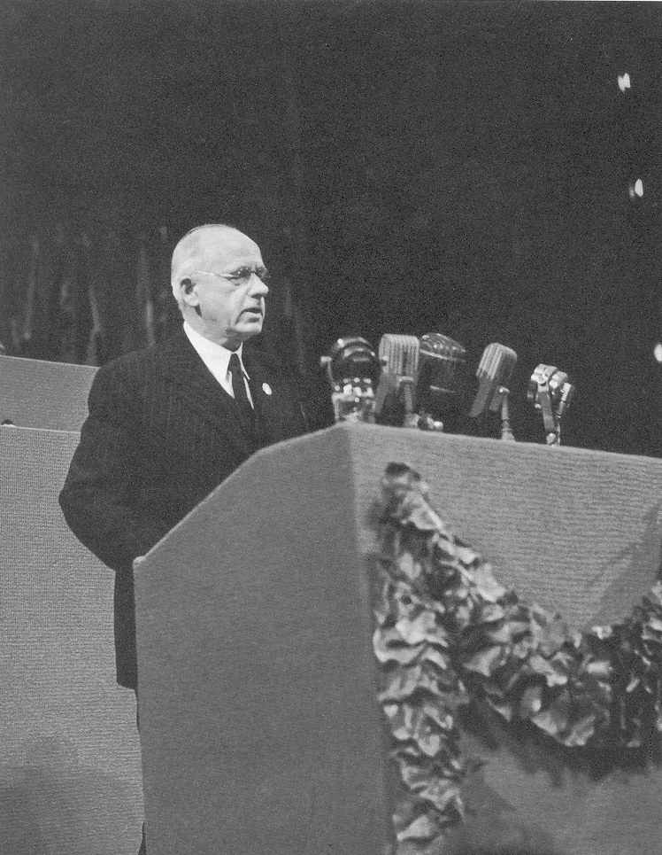
Visions of Human Rights and opposition to Human Rights
For centuries of time, and in many different places, thoughtful men and women have held visions of human rights. They have dreamed of a world in which all people might enjoy certain basic and inherent rights simply by virtue of being members of the same human family. Such visions have contributed much to the long struggle for the worth and dignity of the human person throughout history. In our own century, they have had — and continue to have — a profound influence upon both domestic and international affairs.
Yet, by the same token, over these same centuries of time these visions remained theory rather than practice. During most times and in most places of the world, the prevailing patterns were those of discrimination and dominance based upon gender, race, class or caste, religion, ethnicity, or some other form of difference that divided people from one another. Misogyny, racial prejudice, intolerance, segregation, torture, conquest, and human bondage in serfdom or slavery were the norm rather than the exception, sometimes made all the more acute by cases of genocide. Of particular importance, victims of these practices suffered under governments who confidently knew in advance that how they treated those under their control would be regarded as a matter exclusively within their own domestic jurisdiction, and not at all subject to the scrutiny of other states. This precluded victims from having recourse to assistance beyond their own borders. Throughout most of history, therefore, international human rights did not exist.
“Human rights are not platitudes”
Peter Fraser, New Zealand
Prime Minister, addressing the United Nations

New Zealand's Early Resistance to Human Rights
As those of you who know this nation's history far, far better that I, New Zealand clearly fitted this pattern. When the Japanese proposed that the human right of racial equality be recognised in an international treaty at the Paris Peace Conference in 1919, for example, William Massey immediately opposed it. National sovereignty, he argued, protected New Zealand and other nations of white settlement from outside criticism or interference. His position was endorsed by others, including the Otago Witness, when it declared: “If there is one subject on which there is acute feeling... it is the recognition of the coloured races.” Although the American Declaration of Independence begins by asserting all men are born equal in the sight of God it makes no mention of niggers and Japanese. Worried about the growth of international pressure on this subject, the government passed the 1920 Immigration Restriction Act the next year with the strong support of the Anti-Asiatic Society and the White Race League. Interestingly enough, they believed that in this action they needed to exercise considerable caution and create what the Evening Star described as "a certain amount of delicate camouflage."
Much of New Zealand’s role in the League of Nations revealed a similar attitude. This new experiment sought to undertake a number of activities to promote international human rights. These included efforts on behalf of refugees, the protection of minorities, indigenous peoples under mandates, the rights of women and children, and world health, among others. Yet New Zealand worked to prevent T.W. Ratana from addressing the Assembly and continually complained that the organization was exceeding its authority when it came to human rights. Remarkably, given the nature of Pakiha-Maori relations, one official referred to the League's efforts in minority affairs as being of "only academic interest." When discussing a possible treaty on child welfare, he continued:
The question as to the necessity of an international convention ... was raised, but if I may express a personal opinion, I would say that it is much to be hoped that attempts, of which this is an example, to regulate matters which are national in character, will be brought to an end....

It is thus not hard to understand why other members of the League of Nations regarded New Zealand as an adversary of international human rights, and believed that nothing would change its mind.

Change in the Second World War
They were wrong. Within an extremely short period of time, New Zealand quickly and dramatically transformed itself from being an opponent into one of the worlds' leading champions of human rights. The immediate cause was the Second World War. It is difficult to imagine that a war, lasting for six brutal years and spreading across the globe, causing untold damage and devastation, and resulting in the horrifying deaths of millions of people (some by genocide in the Holocaust), could create new and unanticipated opportunities for the promotion and protection of international human rights. But it did.
Among other things, the experience of the war opened up possibilities to launch a crusade on behalf of human rights. Among the crusaders, it is difficult to find anyone more committed than Peter Fraser or Walter Nash. They were inspired by Franklin Roosevelt's speeches about freedom, and they wholeheartedly endorsed the principles about human rights enunciated in the Atlantic Charter. Indeed, even in private, Nash embraced the Charter and without hesitation boldly predicted that it constituted nothing short of "a declaration more potent for good than any other in the records of human history. They were proud to join other countries in signing the 1942 Declaration of the United Nations, proclaiming their collective commitment "to preserve human rights and justice in their own lands as well as in other lands.
In addition, these leaders of New Zealand spoke frequently, eloquently, and with conviction about this goal — not only at home, but also abroad. Nash addressed often unappreciative audiences in racially segregated Washington, D.C. about equality, and in his capacity as president of the International Labour organization spoke about the universal applicability of the principle that "men and women of all races, of all creeds, of all nationalities, and of all classes" around the world must be accorded their basic human rights. When speaking before the Canadian Parliament, Fraser similarly declared:
The sacrifices made by our men and women ... must not — I speak most seriously and earnestly — be in vain. We are fighting.... for the principles .... of the four freedoms -freedom of speech, freedom of religion, freedom from fear and want — may be established and the masses of people given greater opportunities than ever before. Unless we strive to carry out those principles we shall be undoing in peace what has been won on the battlefield.
It was the possibility of just such an "undoing" that worried Fraser and his colleagues throughout the war. Their fears were more than confirmed in October 1944 when the Great Powers released their Dumbarton Oaks Proposals. Rather than reflecting the principles and the promises of the Atlantic Charter, these plans for the new postwar international organization revealed nothing but power politics. According to the plan, those nations with the most preponderant strength would act as guardians over the rest of the world by dominating a powerful Security Council. A General Assembly would be composed of the representatives of all nations and that an Economic and Social Council would be created, but these would not possess much power. Then, and despite all of the declarations, moving speeches, solemn promises, and crusading rhetoric, the Great Powers resisted including any meaningful articles on human rights. Declared the Soviet representative, Andrei Gromyko, reference to human rights "is not germane to the main tasks of an international security organization."
The crusaders from New Zealand — and, indeed,' most of the rest of the world — reacted to these proposals with a mixture of profound anger, frustration, disappointment, and sense of betrayal. Motivated both by national interests and by idealism, Fraser and Nash lashed out in criticism. Mincing few words, Carl Berendsen reacted to the Dumbarton Oaks proposals directly:
Too much emphasis on Great Powers .... No guarantees, no pledges, no undertaking except in general terms .... no adequate opportunity for small countries like New Zealand to exercise influence or express views .... No adequate machinery for securing peaceful change and economic justice — only words.... It aims too low.
Australian leaders reacted in much the same way, and following a meeting in Wellington during November 1944, issued a joint declaration with New Zealand. They wanted more influence by the smaller powers, a greater role for the General Assembly, the creation of some system on behalf of colonial peoples, and explicit provisions relating to human rights particularly those having to do with social and economic welfare — and said so publicly. Now the shoe was on the other foot, and the British did not like it at all. "In our view," they announced in an unusually sharp comment, "in a matter of this kind all members of the British Commonwealth ought to take every care to co-ordinate as far as possible their respective views before entering public declarations of policy. We can only express our regret that this public announcement has been made ... without prior consultation with, or warning to us.” The replies of both Fraser and Evatt to this protest from London, in the words of even the polite official history, "were, to say the least, unrepentant."
New Zealand joined with many others (also heretofore excluded) to make their voices heard at the San Francisco Conference of 1945. These included other small and medium states, as well as minority groups, peoples still under colonial control, and non-governmental organizations seeking to influence the process. Together they shared several important assumptions:
- that the organization needed to be more representative
- that how nations treat their own people influences the peace
- that a connection existed between peace and social & economic justice
- that the international community had responsibilities to honour the promises made about human rights.
As Peter Fraser declared in his opening statement before the other delegates:
I would, therefore, stress that unless in the future we have the moral rectitude and determination to stand by our ... principles then the procedures laid down in this new organization will avail us nothing ... This is a moment of time which will not recur in our lives and it may never recur again. It is my deep f ear that if this fleeting moment is not captured the world will again relapse into another period of disillusionment, despair, and doom. This must not happen!
In order to keep this from happening Fraser focused his energies upon three different, but related, issues.
- He was elected as the chairman of the committee that addressed colonial issues, and he threw himself into the assignment of being the chairman of the trusteeship committee. Here he could focus upon the welfare of indigenous peoples, the right of self-determination, and upon what he called the vision of "the fundamental rights of men and women" around the world.
- Fraser joined with others to strengthen the proposed powers of the Economic and Social Council and to give it clear responsibilities in the area of international human rights.
- Finally, Fraser worked to insert strong and specific language about human rights into the United Nations Charter. In sharp contrast with the Dumbarton Oaks Proposals, he formally proposed the following language:

All members of the organization undertake to preserve, protect, and promote human rights and fundamental freedoms, and in particular, the rights of freedom from want, freedom from fear, freedom of speech, and freedom of worship.

The United Nations Charter
In the end, the Charter reflected many of these efforts. On matters of principle and purpose, for example, the Charter broke remarkable new ground. In sharp contrast with previous treaties, its Preamble begins with these unusual words: "We the peoples of the United Nations... reaffirm faith in fundamental human rights...." Article 1 speaks to the questions of the major purposes of the organization, and declares that one of the most important of these is that of promoting and encouraging "human rights and fundamental freedoms for all without distinction as to race, sex, language, or religion."
Then, in a matter very close to the heart of Fraser, the Charter speaks to the relation between peace and the welfare of people based upon "respect for the principle of equal rights and self-determination." [55] It raises the Economic and Social Council to the position of one of the "principal organs" of the United Nations. In addition, it provides the mandate for the creation of the UN Commission of Human Rights [68] which went on to draft the important Universal Declaration of Human Rights. This was a most significant development, and prompted Fraser at the end of the conference to say with justifiable pride: "No section of the Dumbarton Oaks proposals underwent more extensive changes for the better than that which dealt with international cooperation in economic and social matters."
Due to the recommendations of Fraser's own committee, the Charter then went on to address the matter of the rights of colonial peoples. It contains an important Declaration Regarding Non-Self -Governing Peoples, explicitly stating that "the interests of the inhabitants of these territories are paramount" and calling for their "just treatment" and "protection against abuses." It goes on to establish the Trusteeship Council and the International Trusteeship System for the administration and supervision of certain colonial territories. of particular importance, the Charter commits members of the organization to promote the development of self-government in these areas and "to encourage respect for human rights and fundamental freedoms for all without distinction.... 11 [73 and 76] Fraser's contributions to these provisions did not go unnoticed. Indeed, no less an individual than U.S. Secretary of State Edward Stettinius wrote in a personal letter:
No one at the Conference has brought higher ideals to our work nor more persistence in seeking to give effect to them. The Chapter on Trusteeship, which owes so much to your guidance, will, I am confident, prove to be one of the most historic of our achievements. You have contributed much to making it a sure basis for the advancement and welfare of untold millions.
These were remarkable achievements. Never before in history had visions of human rights in the world been so openly discussed. Never before in history had such broad-based responsibilities for human rights made an integral part of a negotiated, international agreement.

The Universal Declaration of Human Rights
The Charter of the United Nations, of course, provided the foundation for all subsequent efforts in this area. But it could not attempt to define the precise meaning or elaborate upon the full extent of international obligations to protect human rights. This task was assigned to the Commission on Human Rights which began meeting in early 1946 under the leadership of Eleanor Roosevelt. Under her guidance, the commission worked to draft what they called an "International Bill of Human Rights."
New Zealand was not an original member of the Commission. This did not prevent her, however, from playing an influential role. Indeed, Fraser was not about to let his country remain silent on this issue of human rights. To set a good example, he already had announced that his would be the first country in the world to place any territory under the Trusteeship System, and that the agreement over Western Samoa should itself be "a self-contained Bill of Rights. Shortly thereafter, Carl Berendsen was named chairman of the important Third Committee dealing with Social, Humanitarian, and Cultural Affairs. The New Zealand representative on this committee, Agnes McIntosh, used the opportunity to fervently speak on behalf of equal rights for women wherever they might be. At the same time, Fraser appointed a special Human Rights Committee in Wellington (which included historians F.L.W. Wood and J.C. Beaglehole) to carefully study the draft declaration and covenant, and to send their comments to the United Nations for consideration. He also sent a qualified observer to New York to monitor drafting developments — the only country a non-member of the Commission on Human Rights to do so.
At the same time, Fraser himself led the New Zealand delegation to the Paris session of the General Assembly in 1948 when it debated the Universal Declaration of Human Rights. Joining him were Ann Newlands, a Labour Party stalwart, and Colin Aikman, a young official of the Department of External Affairs. Over a period of three months of meetings, the latter two pressed strongly for the inclusion of economic and social rights and the right to join trade unions. In this regard, they were successful. On two points, however, the New Zealand delegation was far ahead of where others were prepared to go.
First, they argued that the Universal Declaration of Human Rights should include the right of all individuals to petition their government or the United Nations directly. This, they said, was a fundamental right. Subsequent events, of course, demonstrated just how correct they were on this point. But for the moment, this position on human rights was too extreme for the other members.
Second, Fraser and the delegation argued that the United Nations should couple a declaration with a binding covenant on human rights. Stated somewhat differently, they believed that discussions of rights should also entail responsibilities and binding obligations upon states. At the time, both of these positions were far too extreme for other nations. However, the delegation successfully sponsored a resolution calling for the Commission on Human Rights to continue to give priority to working on the covenant and measures of implementation after the adoption of the universal Declaration on 10 December 1948.
These efforts that resulted in the Charter of the United Nations and the Universal Declaration of Human Rights launched a revolution that continues to this day. They inspired a whole series of binding treaties, implementation mechanisms, special procedures, technical assistance, and promotional campaigns on behalf of human rights that transformed individual people from mere objects of international pity into actual subjects of international, law. In this endeavour, Fraser and his colleagues proceeded with idealism, courage, confidence — and a certain level of naivete.
They were not fully aware of all the ramifications or implications of their efforts, nor could they be since this was such a new departure in international relations. Through time it became clear that problems would emerge:
- That there can be a significant gap between the principles of a vision and the actual practice — easier to be a vocal champion with words rather than an implementor with action with reference to a possible covenant, for example, one official from External Affairs [Q. Quentin-Baxter] wrote: "... each nation is afraid that the Covenant, once established as a binding and enforceable instrument, may be used to justify an unwelcomed degree of interference in its domestic affairs."
- That states all too often demonstrate their desire to have their cake and eat it too. The vision: provisions about human rights in the Charter and in the Universal Declaration the practice: Art 2, Paragraph 7:
Nothing contained in the present Charter shall authorize the United Nations to intervene in matters which are essentially within the domestic jurisdiction of any state...these provisions are, quite frankly, contradictory and mutually exclusive
Colin Aikman correctly viewed the difficulty with these words in 1949:
More important, there will be a constant invitation to the United Nations to intervene in what may be properly regarded as the internal affairs of a sovereign state. Nevertheless, it is this very encroachment of the international community into the affairs of states which lies at the root of all progress in the field of human rights.
- That governments may change and that the normative values of one state might not be those of another.
- That states all too often demonstrate their capacity to see the speck in the eyes of others while ignoring the mote in their own.
The New Zealand delegation seemed genuinely shocked, for example, when others raised questions about human rights as it related to Asian immigration or to the treatment of Maoris in discussing the right of self-determination a little later, for example, one official [McIntosh] wrote:
... the step taken... in discussing self-determination ... may have some remote possibility of weakening our position if the Maoris in fifty years, or one hundred years, hence decide to take an unhelpful attitude. I must confess that I don't understand the implications of all this human rights business....
These problems were very real — but they were in the future. For the moment, New Zealand could take justifiable pride in being a major leader in the movement for human rights — a role not generally known and certainly not fully appreciated. On the subject of human rights it was far out in front of most other nations in the world. It exercised an influence far out of proportion to the size of the country or any previous role in international relations. Thus, for Fraser, his colleagues, and the country, the work on the Charter of the United Nations and the Universal Declaration of Human Rights was indeed "a very special moment in history."

Reprinted with permission

