Human Rights & other curriculum themes/
special programmes

Curriculum themes
Applying a human rights and responsibilities lens can add considerable value to, provide a coherent framework for, and help generalize learning from, activities that come under the following:
Citizenship education
Global education
Peace education
Peer support & mediation
Religious education
Restorative justice
Education for Sustainability/Environmental education/
Treaty education
UNESCO Associated Schools Project
Values education
Work in each of these areas also adds to human rights learning.

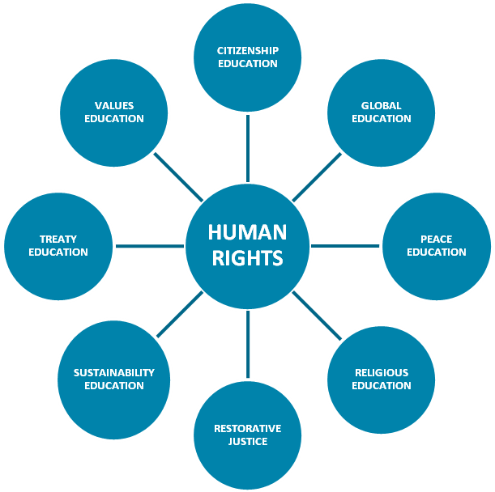

Citizenship education
In their 2005 book, Empowering Children, Brian Howe and Katherine Covell explain cogently why traditional approaches to citizenship fail and a human rights-based approach succeeds. Civic education tends to focus on the arcane mechanics of voting systems and parliamentary procedure to be used sometime in the future when young people attain voting age. For many students the content is dry and irrelevant.
There are compelling reasons to take a human rights-based approach to citizenship education, particularly in New Zealand:
- Citizenship is defined by rights and responsibilities.
Citizenship, n. The status of a citizen with its attendant rights, duties, and privileges
- The Universal Declaration of Human Rights (UDHR) is the most authoritative statement of the rights and duties of citizens everywhere, providing a platform for non-partisan education in what it means to be a New Zealand and global citizen.
- The UN Convention on the Rights of the Child makes it clear that children are citizens, with rights and responsibilities that apply to them now, not in the future. The Convention gives students and teachers a coherent framework to practise active citizenship as part of school life. The immediate application of the UN Convention on the Rights of the Child to children’s lives contributes to engaged and effective learning.
- Addressing elements of New Zealand’s history from a human rights perspective – eg the Treaty of Waitangi, Parihaka, the 1940s campaign for human rights – helps build a sense of New Zealand citizenship.
- Using the human rights framework provides a link between New Zealand and global citizenship.
Everyone has duties to the community in which alone the free and full development of his/her personality is possible.
In the exercise of his/her rights and freedoms, everyone shall be subject only to such limitations as are determined by law solely for the purpose of securing due recognition and respect for the rights and freedoms of others and of meeting the just requirements of morality, public order and the general welfare in a democratic society.
Universal Declaration of Human Rights Article 29

Global education
Global education has been defined as a process which enables people to:
- Understand links between their own lives and the lives of people throughout the world;
- Develop skills, attitudes and values to bring about a more just and sustainable world.
(Global Education Centre)
The international human rights framework is both a manifestation of globalisation, and provides the ethical framework for globalisation.

Peace education, Peer support & mediation
[R]ecognition of the inherent dignity and of the equal and inalienable rights of all members of the human family is the foundation of freedom, justice and peace in the world.
[I]t is essential, if man is not to be compelled to have recourse, as a last resort, to rebellion against tyranny and oppression, that human rights should be protected...
Universal Declaration
of Human Rights
Understanding human rights and responsibilities is integral to “helping students to understand and transform conflict in their own lives, in the community and in the world at large” (Peace Foundation).
The win-win approach underpinning peer mediation programmes such as the Peace Foundation’s Cool Schools programme is enhanced by having explicit regard for the human rights of all involved in conflict.

Religious education
Many religious thinkers contributed to the development of the international human rights framework, and freedom of thought, conscience, and religion is one of the most fundamental human rights.
Teaching about religions and beliefs has been seen as a valuable means of fostering a general climate of mutual respect and understanding within society in order to fulfil human rights obligations regarding freedom of thought, conscience and religion.
One powerful way of building respect for different religions is to explore how they manifest human rights values based on the inherent dignity of human beings.
The OSCE Office for Democratic Institutions and Human Rights has published useful guidelines (Toledo Guiding Principles) on teaching about religions and beliefs in public schools in ways that reinforce human rights. (See http://www.osce.org/item/28314.html)

Restorative justice
Seeking better means of recognising the rights and responsibilities of all involved when difficult behaviour issues arise, a growing number of schools have introduced alternatives to traditional punitive and exclusionary methods based on restorative justice principles.
Restorative justice practices aim to create a ‘climate of care’ and a school culture based on principles of inclusion, the repair of harm, and reintegration, reinforced by strong support networks.
They enable schools and communities to work together rather than being forced into adversarial relationships through traditional disciplinary processes.
Explicit reference to the human rights and responsibilities can be expected to reinforce both the restorative practices and human rights learning.

education for sustainability/environmental education
Article 29 of the UN Convention on the Rights of the Child requires that school education be directed to a range of human rights objectives, including “development of respect for the natural environment.”
Concern for human rights is both the primary reason for caring for the environment, and a necessary consideration when pursuing sustainability.
Sustainability is essential for the realisation of the human rights of future generations – such as the right to a standard of living adequate for health and well-being (UDHR article 25). And measures to protect the environment are not in themselves likely to be sustainable if they do not take into account the human rights of current populations (social sustainable).
Explicit reference to human rights and responsibilities reinforces both sustainability/ environmental education and human rights learning.

Treaty education
Applying a human rights and responsibilities lens can provide a fresh and powerful look at the Treaty of Waitangi and help ground human rights learning firmly in a local context.
See Human rights and the Treaty of Waitangi

UNESCO Associated Schools Project NETWORK (ASPnet)
ASPnet is “a network of schools interested in carrying out activities and in order to improve quality education, particularly its ethical, cultural and international dimensions by developing effective teaching approaches, methods and materials.” As the main purpose of UNESCO is to contribute to peace and security by promoting the collaboration of nations through education, science and culture, in order to further universal respect for human rights, membership of ASPnet fits well with participation in the Initiative.

Values education
A human rights and responsibilities approach adds to other “values education” approaches by linking values to:
- a cross-culturally agreed framework
- norms that apply to relationships between governments and transnational organisations as well as at the personal level.

A framework for special programmes
There are, of course, numerous specific programmes currently running in schools aiming to address specific human rights issues and problems such as bullying, discrimination, harassment and low achievement levels.
Adopting an overall human rights framework and casting these programmes in an explicit human rights light can help integration and manageability and reinforce the programmes themselves as well as general human rights learning.
Principals in schools practising human rights-based education report that such an approach both leads schools examining specific programmes to deal with human rights issues they become more aware of, and a reduction in the need for such programmes as the school’s human rights culture is strengthened.

Brian Howe & Katherine Covell’s book, Empowering Children: Children’s Rights Education as a Pathway to Citizenship (University of Toronto Press, 2005)

