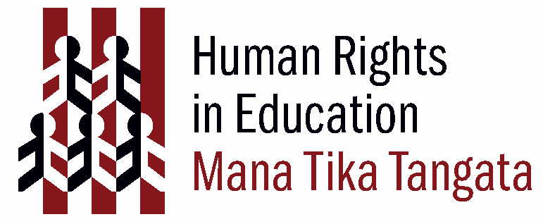
What are children’s rights?
(Adapted from OHCHR (2003) ‘ABC: Teaching Human Rights – Practical activities for primary and secondary schools. Page 27. Download this resource from http://www.unhchr.ch/html/menu6/2/abc_text.pdf)

Rationale
To develop children’s understanding that as young people they are afforded special rights and concurrent responsibilities. To empower them in the knowledge that an internationally recognised set of rights affirm their citizenship in the here and now.

Curriculum
Learning areas
Social sciences
English

Values
Respect for self, others & human rights
Excellence
Equity
Community & participation
Integrity

Key Competencies
Thinking
Using language, symbols, and texts
Managing self
Participating and contributing

Achievement objectives
Level 1 (Social Studies): Understand that people have different roles and responsibilities as part of their participation in groups.
Level 2 (Social Studies): Understand how people make choices to meet their needs and wants.
Level 3 (Social Studies): Understand how groups make and implement rules and laws.
Level 4 (Social Studies): Understand how formal and informal groups make decisions that impact on communities. Understand how people participate individually and collectively in response to community challenges.

Links to other learning areas
The Arts
Health & physical education

Human Rights
 | International Bill  of Human Rights | UNCRoC
Freedom from discrimination | UDHR 2 | CRC 2
Right to life | UDHR 3 | CRC 6,37
Freedom from torture or cruel, inhuman or degrading treatment | UDHR 5 | CRC 37
Right to recognition in law | UDHR 6 | CRC 8
Right to equality before the law | UDHR 7
Right to effective remedy for violation of rights | UDHR 8 | CRC 37
Freedom from arbitrary arrest or detention | UDHR 9 | CRC 37
Right to a fair hearing, presumption of innocence | UDHR 10,11 | CRC 40
Rights to privacy, reputation | UDHR 12 | CRC 16
Freedom of movement | UDHR 13 | CRC
Right to seek safety from persecution | UDHR 14; | CRC 22
Right to a nationality | UDHR 15 | CRC 7
Right to marriage & family, support for family | UDHR 16 | CRC 5,9,10,11.20,21,37
Right to own property | UDHR 17 | CRC
Freedom of thought, conscience and religion | UDHR 18 | CRC 14
Freedom of opinion & expression | UDHR 19 | CRC 13,17
Right to information | UDHR 19 | CRC 17
Right to peaceful assembly and association | UDHR 20 | CRC 15
Right to social assistance | UDHR 22 | CRC 18,26
Right to decent work | UDHR 23 | CRC 32
Right to rest and leisure | UDHR 24 | CRC 31
Right to an adequate standard of living for health and well-being | UDHR 25 | CRC 27
Right to health | UDHR 25 | CRC 24
Right to education | UDHR 26 | CRC 28,29
Right to know human rights | Preamble to UDHR | CRC 42
Right to participate in cultural life | UDHR 27 | CRC 30
Right to benefit from science | UDHR 27
Right of child to have best interests as primary consideration in decision making |  | CRC 3
Right of child to express views in all matters affecting him/her |  | CRC 12
Rights of children with disabilities |  | CRC 23

Activity

Type of activity
Discussion, reading, critically thinking.

Preparation
Prepare copies of a simplified version of the United Nations Convention on the Rights of the Child to distribute.

Materials
Copies of UNCROC, pens and paper for brainstorming ideas, whiteboard for collating group ideas.

Time Frame
1-2 hours

Activity steps
Ask students whether there are rights and responsibilities that apply more specifically to them, not just as people but as young people – as children. What might it be wrong to do (or not to do) to someone just because he or she happens, at that point in time, to be “a child”?

Introduce the Convention on the Rights of the Child, explaining that it guarantees to children the things they need to grow up healthy, safe and happy and to become good citizens in their community.

Help children understand the relationship between needs and rights by discussing:

• Why do you think the United Nations has adopted a document just for
children’s human rights? How are children’s needs different from those of
adults?

• Why do children need special protection? Give some examples?

• Why do children need special provisions for their welfare? What do
children need for their survival, happiness and development?

• Why do children need to participate in their communities? Give some
examples.

• Who is responsible for seeing that children’s rights are respected? (e.g.
parents? teachers? other adults? other children? the Government?)

* for upper Primary School or Intermediate

Guidelines
It may work well to get students to discuss the activity questions in small groups, brainstorming answers - and then report back to the class.

Extension
Ask students to evaluate how well their rights under UNCROC are met by their school. Which rights does the school need to work on and what might be the best ways to go about this.
Ask children to evaluate how well they are living up to the concurrent responsibilities attached to these rights e.g. are they respecting their right to participation by offering sensible, well thought out opinions?

Modifications
It may help to include a simplified version of the UDHR in the resources given to students to highlight the differences and similarities between the rights afforded to all people and those specially relevant to children.

