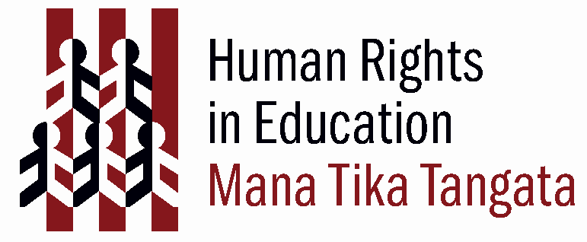
People Around Me

(Adapted from OHCHR (2003) ‘ABC: Teaching Human Rights – Practical activities for primary and secondary schools. Page. 26. Download this resource from http://www.unhchr.ch/html/menu6/2/abc_text.pdf )

Rationale
To develop an understanding in children of the importance of human rights in establishing mutual respect between all people.

Curriculum
Learning areas
Social sciences
The Arts

Values
Respect for self, others & human rights
Diversity
Equity
Community & participation
Integrity

Key Competencies
Thinking
Managing self
Relating to others
Participating and contributing

Links to other learning areas
Health & physical education
Learning languages

Human Rights
 | UDHR Articles | UNCRoC Articles
Freedom from discrimination | UDHR 2 | CRC 2
Freedom of movement | UDHR 13
Freedom of thought, conscience and religion | UDHR 18 | CRC 14
Right to know human rights | Preamble to UDHR | CRC 42
Right to participate in cultural life | UDHR 27 | CRC 30
Right to a free and fair community | UDHR 28;
Duty to the community so human rights can be realised | UDHR 29;

Activity

Type of activity
Discussing, thinking critically, forming group consensus.

Preparation
Make space for a talking circle, with a white board within view to collate ideas.

Materials
Pens and paper.

Time Frame
50 approximately, depending on discussion time.

Activity steps
Ask children in a talking circle to think of a good quality in themselves or ask “What are some qualities we admire in people?” Then lead a discussion on these topics:

- Do you respect in others the quality you like about yourself?
- Do you respect good qualities in others that you do not have?
- Do all human beings deserve respect? Why?
- How do you show respect for others?

Next ask children to think of a time when they felt hurt because someone did not respect them.

- How did disrespect feel?
- Why do people sometimes act disrespectfully to others?
- What is dignity? Is your dignity hurt when others do not respect you?
- What can you do when others do not respect you?

Finally,

- Ask “What does it mean if we say that all human beings deserve respect?”
- Ask for examples of how life in their community could be more peaceful if people showed greater respect for each other.
- Ask children to think of one way they could show respect for someone.

Guidelines
You may want to split children into smaller groups in this activity and have them report back to the main group with their findings.

Extension
Ask children to map the topic of developing respect to the UDHR or UNCROC. Which rights are essential in creating relationships of mutual respect and understanding?
As a follow up exercise ask children to find articles in the media illustrating the theme of respect - or lack of- in their local community and the world at large.

