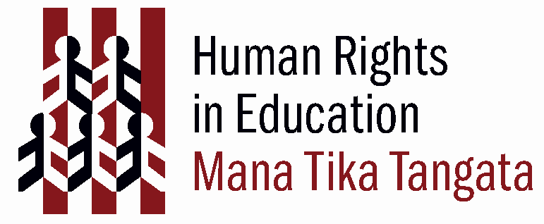
Me on the wall
(Adapted from OHCHR (2003) ‘ABC: Teaching Human Rights – Practical activities for primary and secondary schools. Page. 22. Download this resource from http://www.unhchr.ch/html/menu6/2/abc_text.pdf)

Rationale
Through encouraging children to learn about the similarities and differences between them and their peers, a concurrent appreciation for diversity, equality and the universality of many human traits can be fostered.

Curriculum
Learning areas
Social sciences
The Arts

Values
Respect for self, others & human rights
Innovation, inquiry & curiosity
Diversity
Equity

Key Competencies
Thinking
Using language, symbols, and texts
Relating to others
Participating and contributing

Achievement objectives
Level 1 (Social Studies): Understand that people have different roles and responsibilities as part of their participation in groups.
Level 2 (Social Studies):
Understand how cultural practices reflect and express people’s customs, traditions, and values.

Links to other learning areas
English

Human Rights
 | International Bill  of Human Rights | UNCRoC
Freedom from discrimination | UDHR 2 | CRC 2
Freedom from torture or cruel, inhuman or degrading treatment | UDHR 5 | CRC 37
Right to equality before the law | UDHR 7
Right to a nationality | UDHR 15 | CRC 7
Freedom of thought, conscience and religion | UDHR 18 | CRC 14
Freedom of opinion & expression | UDHR 19 | CRC 13,17
Right to know human rights | Preamble to UDHR | CRC 42
Right to participate in cultural life | UDHR 27 | CRC 30

Activity

Type of activity
Discussion, self analysis, formulating questions.

Preparation
Gather materials, make sure children have adequate desk space/floor space to make large posters or drawings on the ground.

Materials
Pens and Large pieces of paper or chalk

Time Frame

Activity steps
- Trace the outline of each child on a large piece of paper (best done lying) or on the ground.

- Have students draw in physical details and then write their personal and physical qualities around the figure: e.g. name, height, weight, culture, religion, what the children would most like to learn or do at school, or in adulthood.
- If you have used papers, pin them up around the wall.
- Set up discussion between students so they can learn about each other as well as themselves.

* for Lower Primary School

Extension
You could have students report back to the class on what they have picked out as important characteristics for themselves.
Students could also be put into small groups and asked to write up a table of similarities and differences between them.

