Sponsoring organisations
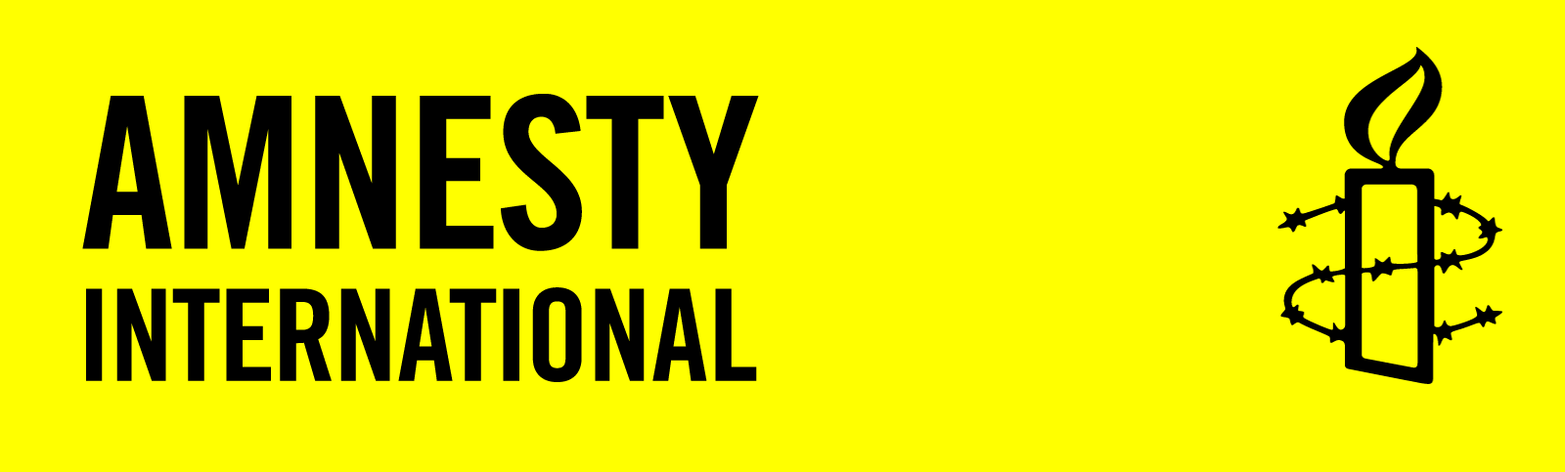 | AMNESTY INTERNATIONAL AOTEAROA NEW ZEALAND (AINZ)  Amnesty International (AI) is a global movement of over 2.2 million people, including 8,000 in New Zealand, who contribute their time, expertise and funds to promoting human rights and international campaigning against some of the most serious violations. AINZ wishes to see New Zealand develop as a country that provides courageous and creative human rights leadership in the 21st century, and that is as well known for its defence of human rights as its rugby. AINZ has groups in over 100 secondary schools.
 | CHILDREN’S COMMISSIONER  The Children's Commissioner speaks out on behalf of all children and young people in Aotearoa New Zealand to ensure their rights are respected and upheld. An independent authority, the Children’s Commissioner promotes their wellbeing through advocacy, consultation, monitoring, research and investigation.
DEVELOPMENT RESOURCE CENTRE
The Development Resource Centre (DRC) is New Zealand’s specialist centre on international development and global issues. Seeking to inform and educate people to take action to create a just world, the Centre aims to increase the knowledge, understanding and realisation of human rights. Its Global Education Centre works to build the capacity of teachers and other educators to engage with global issues with a human rights perspective.

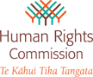 | HUMAN RIGHTS COMMISSION - TE KÂHUI TIKA TANGATA  The Commission champions fundamental human rights as a framework for a fair and just society for all the people of New Zealand. The Commission's vision is that New Zealanders know their rights, acknowledge their responsibilities and respect the rights of others. An independent statutory body, its functions include encouraging the maintenance and development of harmonious relationships between individuals and among the diverse groups in New Zealand society.
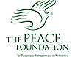 | THE PEACE FOUNDATION  The Peace Foundation (Foundation for Peace Studies Aotearoa/New Zealand) recognises that respect for human rights is an essential component of societies at peace. The Foundation helps to establish and maintain peaceful and non-violent relationships by teaching rights-respecting skills that encourage better communication, co-operation and non-violent conflict resolution.

