Building human rights communities in education: a New Zealand initiative
Human Rights Communities in Education is a collaborative initiative aimed at New Zealand’s schools and early childhood education centres developing as communities in which human rights and responsibilities are known, promoted and lived.

Making things easier not harder
The Initiative is not another programme to be fitted into an already crowded overall school programme. Human rights-based education is a general whole-school approach to teaching, school organisation and learning that brings coherence and adds value to many things schools do already.
It does mean learning a basic framework, but teachers have found that applying the framework improves the learning environment, reducing stress, and provides a toolkit that can readily be applied by students and teachers across the curriculum.
Joining the Initiative can help schools
- Develop a school curriculum based on the principles of the New Zealand curriculum
- Encourage, model and explore the agreed values and develop the key competencies
- Reinforce pedagogy that promotes student learning
- Meet key achievement objectives across the learning areas
- Meet key requirements for Boards of Trustees, including the NEGs & NAGs

In schools taking the Initiative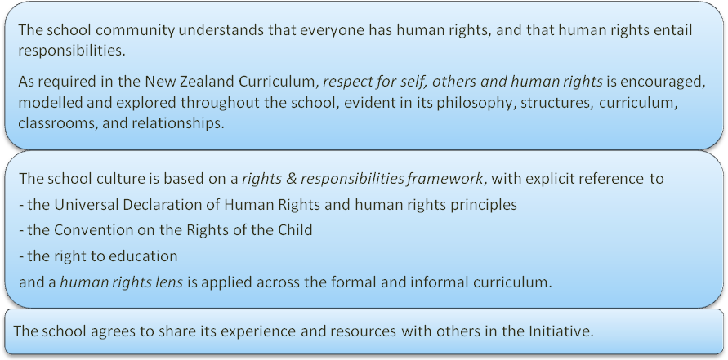

A tight-loose approach: diversity rather than prescription
While there is a core to the Initiative – based on what has shown to work elsewhere – the power of human rights-based education is in the participatory approach that is a hallmark of human rights approaches, and the diversity that is possible based on a clear common theme (human dignity, rights & responsibilities, using the human rights framework).

A framework for special programmes
There are, of course, numerous programmes currently running in schools aiming to address specific human rights issues and problems such as bullying, discrimination, harassment and low achievement levels. These existing programmes are encouraged as part of the Initiative but within an all-embracing human rights and responsibilities framework that helps integration.
Principals in schools practising human rights-based education report that such an approach both leads schools examining specific programmes to deal with human rights issues they become more aware of, and a reduction in the need for such programmes as the school’s human rights culture is strengthened.

A New Zealand approach
Although it draws on international experience in human rights-based education in Canada, Ireland and the UK (to name a few), the Initiative is developing a unique New Zealand approach to human rights that includes, for example, developing an understanding of the human rights dimensions of the Te Tiriti o Waitangi.

Behind the initiative
The Initiative is part of New Zealand’s Action Plan for Human Rights – based on the contributions of over 5,000 individuals, groups and organisations – and is backed by the Children’s Commissioner, Human Rights Commission, Amnesty International, Development Resource Centre and Peace Foundation, and supported by Sir Paul Reeves and Dame Silvia Cartwright. Central support for the Initiative has been made possible by financial assistance from the Todd Foundation and JR McKenzie Trust.

