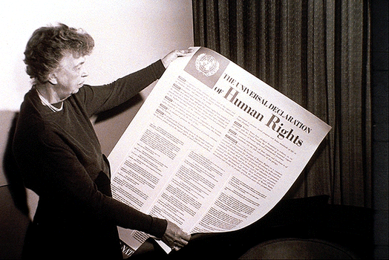
A Universal Declaration
Eleanor Rooseveldt
Chair of the UN Commission on Human Rights

The adoption of the Universal Declaration of Human Rights (UDHR) by the UN General Assembly on 10 December 1948 was a milestone: cross-cultural international agreement for the first time that all people everywhere were entitled to certain basic rights by virtue of being human.
Lord Cooke of Thorndon – arguably New Zealand’s most eminent jurist – described it as one of the most significant dates in world history.

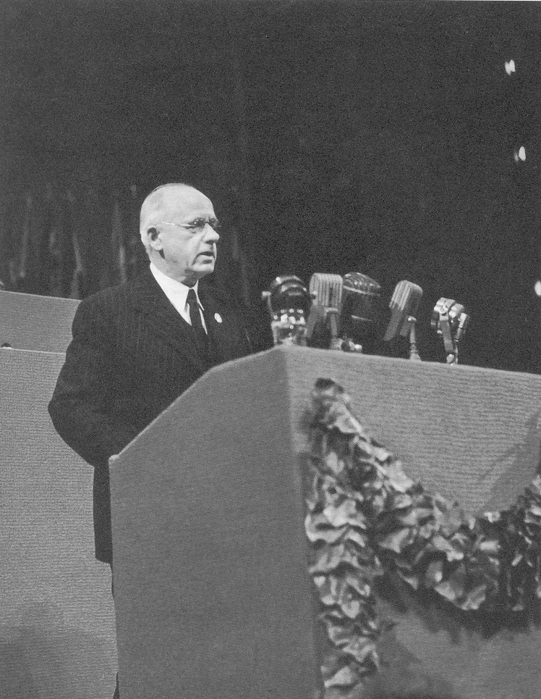
Towards a declaration
“Human rights are not platitudes”
PM Peter Fraser addressing the UN
During World War 2 there was considerable public discussion about “War Aims”. In October 1939 H.G.Wells wrote to The Times and, citing the failure to create a better world after WW1, suggested that a “Declaration of Rights” in the tradition of the Magna Carta was needed. Addressing the US Congress in January 1941 Franklin Roosevelt said “we look forward to a world founded upon four essential human freedoms”. In August Roosevelt and Churchill declared in the Atlantic Charter their “hope to see established a peace... which will afford assurance that all the men in all lands may live out their lives in freedom from fear and want”.
New Zealanders Peter Fraser (Prime Minister) and Walter Nash (Finance Minister) campaigned strongly for human rights and New Zealand signed the 1942 Declaration of the United Nations “to defend life, liberty, independence and religious freedom, and to preserve human rights and justice in their own lands as well as in other lands”. They argued passionately on the international stage that human rights needed to be central to the post-war world order, and strongly resisted attempts at the end of the war to water down human rights commitments in the UN Charter being drafted.
The UN Commission on Human Rights, chaired by Eleanor Roosevelt, was given the task of elaborating on the human rights commitments contained in the UN Charter. It drew on the work of a UNESCO philosophers’ committee that sought the views of scholars and leaders reflecting all the major cultural traditions.
The Universal Declaration was finally adopted by 48 votes in favour and eight abstentions. The President of the General Assembly, Australia’s HV Evatt, said that the Declaration “was backed by the authority of the body of opinion of the United Nations as a whole and millions of people, men, women and children all over the world, would turn to it for help, guidance and inspiration”.

The declaration
In the preamble, the General Assembly declared that
- “recognition of the inherent dignity and of the equal and inalienable rights of all members of the human family is the foundation of freedom, justice and peace in the world”
- “disregard and contempt for human rights have resulted in barbarous acts which have outraged the conscience of mankind”
- “the advent of a world in which human beings shall enjoy freedom of speech and belief and freedom from fear and want has been proclaimed as the highest aspiration of the common people”
- “it is essential, if man is not to be compelled to have recourse, as a last resort, to rebellion against tyranny and oppression, that human rights should be protected by the rule of law”
- the peoples of the United Nations have in the Charter reaffirmed their faith in fundamental human rights, in the dignity and worth of the human person and in the equal rights of men and women”.
In 30 articles, the Universal Declaration covers civil, political, economic, social and cultural rights including the right to life, freedom from discrimination, freedom from fear and injustice, the right to an adequate standard of living, and the right to education to fulfil all human rights.
The General Assembly called on “every individual and every organ of society” to promote the human rights outlined in the Declaration “by teaching and education”, and called upon all Member countries to publicize the text of the Declaration and "to cause it to be disseminated, displayed, read and expounded principally in schools and other educational institutions”.

International law
The Universal Declaration is given practical force in international law through a range of human rights treaties, many of which explicitly mention children.
The Universal Declaration was followed by two key treaties: the International Covenant on Civil and Political Rights and the International Covenant on Economic, Social and Cultural Rights. Together the three constitute what is known as the International Bill of Human Rights.
Having being reaffirmed by the world’s governments in key UN conferences and leader summits in 1993, 2000 and 2005, the Universal Declaration is now regarded by many as having the force of international common law.

Freedom of speech and expression, freedom of worship, freedom from want, and freedom from fear.
Byelorussian SSR, Czechoslovakia, Poland, Saudi Arabia, Ukrainian SSR, Union of South Africa, USSR, Yugoslavia.

